Directions:

1. Replace images in this document and text prompts with the correct information, i.e. “Artist Name” with your name.
2. You can additionally add images, particularly if you’re able to include photos of work in situ to help illustrate the scale of your works but aim for a total of 10 -15 images total that best represent your work in the field of Australian Landscape painting.
3. For “additional information” consider elaborating on the medium and process of creating the work, the subject matter, or if the work was part of a larger series of works.
4. Delete this page.
5. Save as word doc or export as and adobe .pdf with your surname in the filename, i.e. “Artist Name_Urbach_2025.”

Artist Name

The Urbach Application portfolio

2025

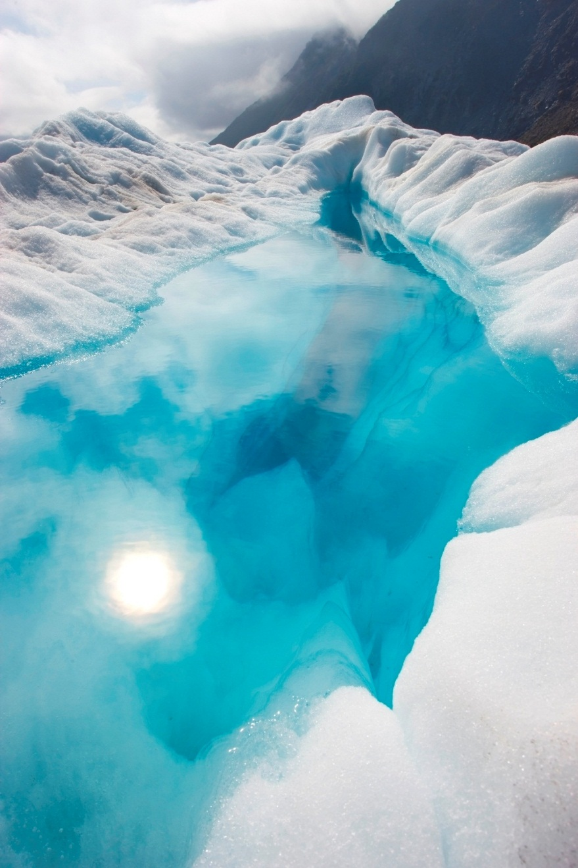

Artwork title, year

medium

dimensions

Additional information



Artwork title, year

medium

dimensions

Additional information



Artwork title, year

medium

dimensions

Additional information



Artwork title, year

medium

dimensions

Additional information



Artwork title, year

medium

dimensions

Additional information



Artwork title, year

medium

dimensions

Additional information



Artwork title, year

medium

dimensions

Additional information



Artwork title, year

medium

dimensions

Additional information



Artwork title, year

medium

dimensions

Additional information



Artwork title, year

medium

dimensions

Additional information