Instructions on using the Portfolio Tempplate:
- Replace each image (the glacier photos) in this document with your own. Resize as needed.
- Add in your relevant artwork information on each page, i.e. replace “Artist Name” with your name.
- For “additional information”, you can delete or provide the following:
  - if the work is part of an edition
  - if the work has been exhibited before and where
  - if the work is a moving image, performance, or sound artwork, provide a link to a viewable file on Youtube, Vimeo, or your website with any passwords if necessary
- Delete excess pages (SAM Spotlight applications should include 5-8 artworks and their details).
- Delete this page.
- Save and export as a .pdf with your surname in the filename, i.e. “Artist Name_Spotlight_YEAR.”

Alternatively, you can create your own document / template mimicking this layout.

Artist Name
SAM Spotlight portfolio
YEAR

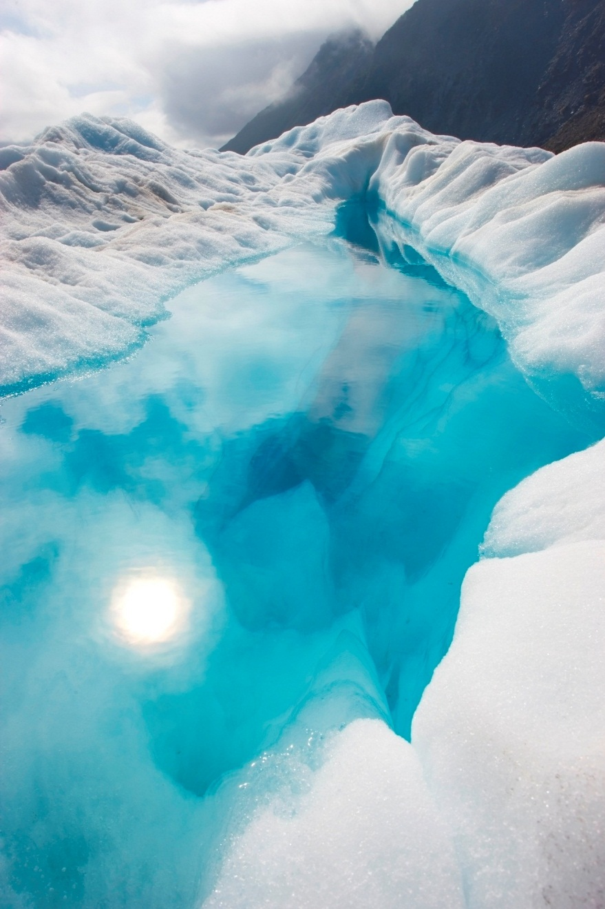

Artwork title, year
medium
size (height x width x depth in cm)
Additional information

Artwork title, year
medium
size (height x width x depth in cm)
Additional information

Artwork title, year
medium
size (height x width x depth in cm)
Additional information

Artwork title, year
medium
size (height x width x depth in cm)
Additional information

Artwork title, year
medium
size (height x width x depth in cm)
Additional information

Artwork title, year
medium
size (height x width x depth in cm)
Additional information

Artwork title, year
medium
size (height x width x depth in cm)
Additional information

Artwork title, year
medium
size (height x width x depth in cm)
Additional information

