Instructions on using the Proposed Artwork Template:
- Update the cover page.
- Duplicate the artwork page as many times as needed so that there is one page and set of details per proposed artwork for the show.
- Replace each image (the glacier photos) and resize as needed in this document to proposed artworks for the show.
- Add in relevant artwork information on each page, i.e. replace the words Artwork title with the title of the proposed work.
- For “additional information” please note:
  - if the work is part of an edition
  - if the work has been exhibited before, and where
  - Any resources needed for display, or installation notes such as if the work needs a plinth, etc.
  - If the work is a moving image, performance, or sound artwork, provide a link to a viewable file on Youtube, Vimeo, or your website with any passwords if necessary.
  - If the work is unfinished, please note ‘work in progress’
- Delete any instructions in red.
- Delete this whole page.
- Save and export as a .pdf with your surname in the filename, i.e. “Applicant Name_Selects_YEAR.”

Alternatively, you can create your own document / template mimicking this layout.

COVERPAGE
SAM Selects 2026 - Proposed Artworks
Exhibition Title
Names of Artists in the Show

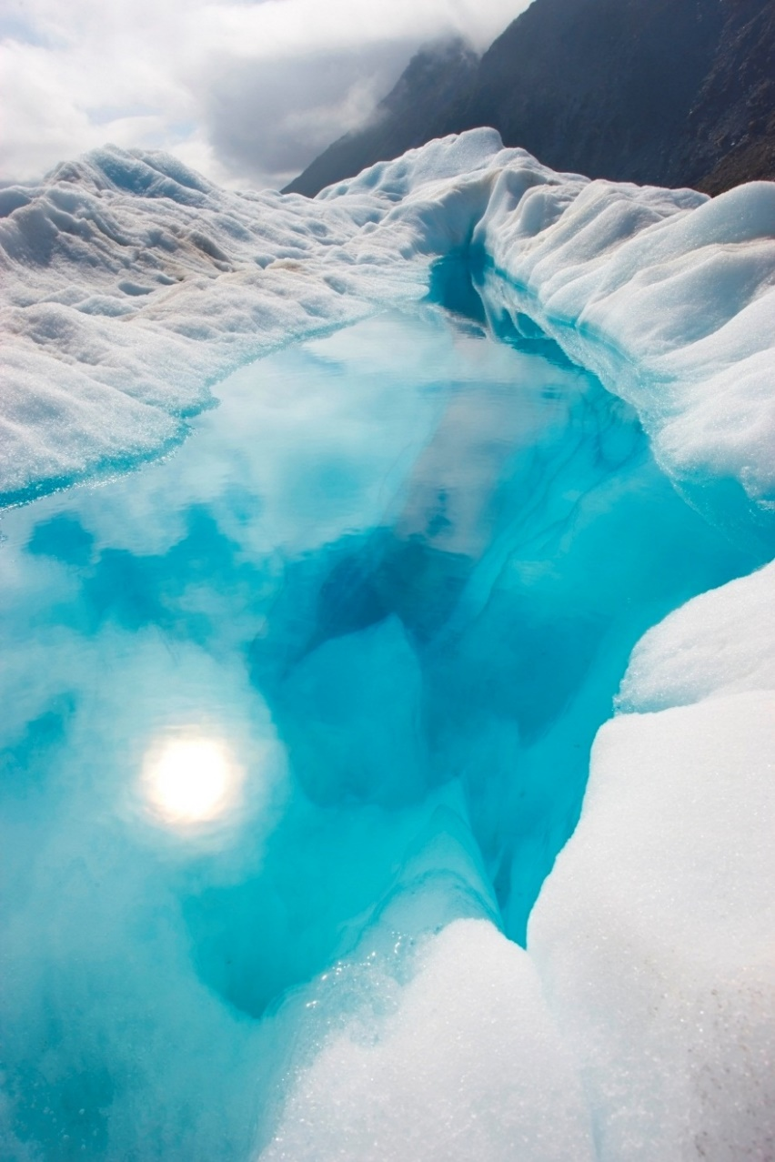
ARTWORK PAGE

Artist Name
Artwork title, year
medium
size (height x width x depth in cm)
Additional information

